BIG DATA ANALYTICS LAB

Assignment-3 Name- Ajit Singhal Course-B.Tech(CS)

Section-A1

Roll No.- 04 University Roll No.-201500052

**Functions, Data Frames & R Factors using R Programming Language**

# Write a R program to perform below operations using R User-Defined Functions –

1. Creating and Calling User-Define Function

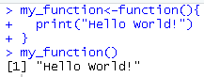

1. Number of Arguments

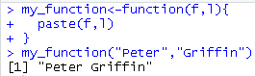

1. Default Arguments

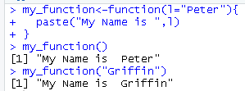

1. Return Values

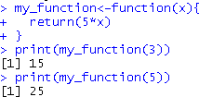

1. Nested Functions

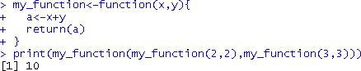

1. Recursion

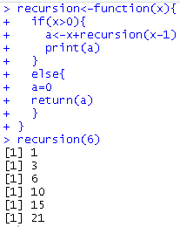

# Write a R program to perform below operations using Data Frames –

1. Create Data Frame

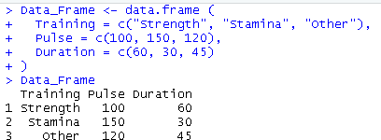

1. Summarize the Data

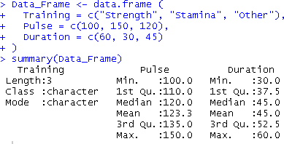

1. Access Items

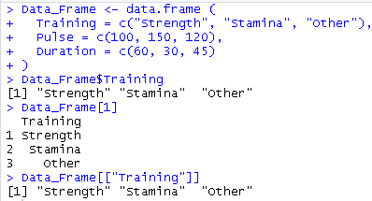

1. Add Rows & Columns

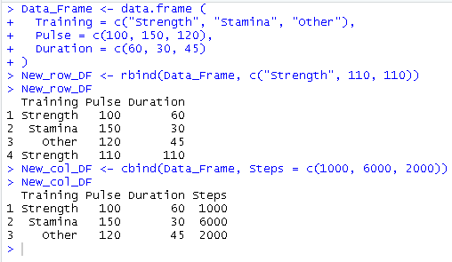

1. Remove Rows and Columns

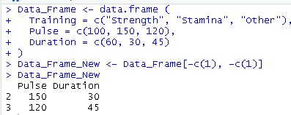

1. Amount of Rows and Columns

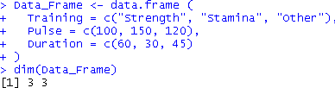

1. Data Frame Length

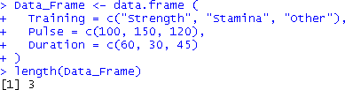

1. Combining Data Frames

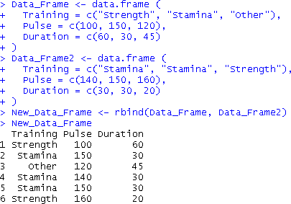

# Write a R program to perform below operations using R Factors –

1. Create a factor

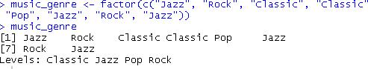

1. Factor Length



1. Access Factors



1. Change Item Value



1. Print the levels using levels( ) function

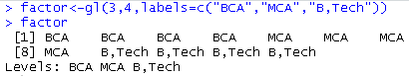

# Create R Factors in Data Frame that prints data with a column of text into categorical form using R Factor.

